GROUND ENHANCEMENT COMPOUND
MEG – MORE EFFECTIVE GROUNDING

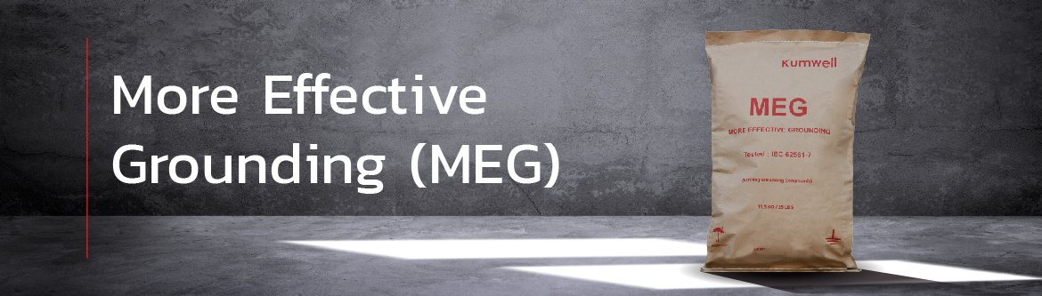

Kumwell MEG (More Effective Grounding) is an alternate solution for effectively reducing ground resistance of the soil surrounding the electrode instead of adding more grid conductors or more ground rods. Kumwell MEG is under the requirements of IEEE Standard 80-2013 with a resistivity of 0.03 Ω-m. It does not dissolve, decompose, and leach out by water and does not leach any toxic, sulfur, or other environmental regulation substances. Kumwell MEG manufacturing is environmentally friendly, reliable, high quality, and enduring. Moreover, it is very effective in poor conductive areas such as rocky soil .
